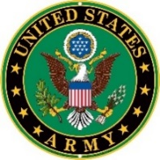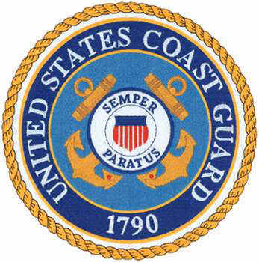

NORTH MYRTLE BEACH VFW POST 10804
Commander – BOB SEDELOW Auxiliary President – MO SEDELOW

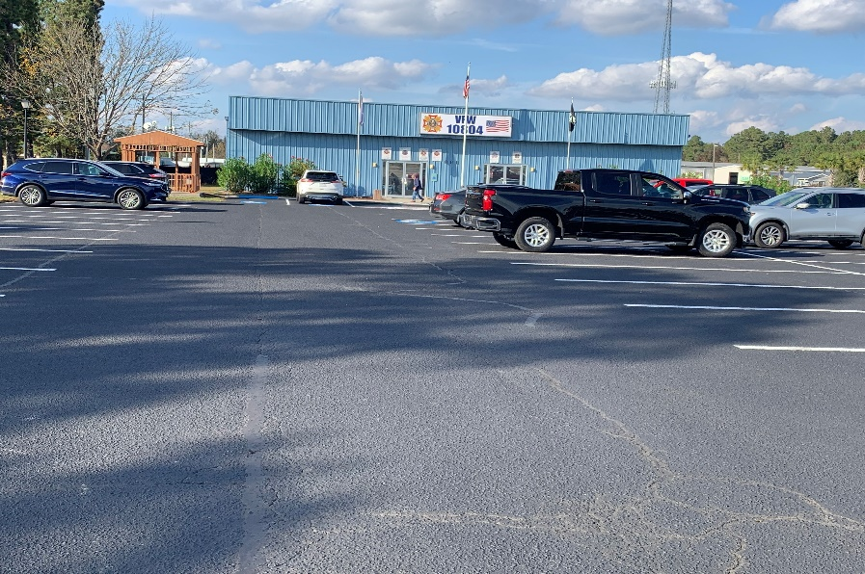
111 Hwy 57 North, Little River SC 29566
843-399-0877 or VFW Post 10804.com, or you can find us on Facebook
Open 7 Days a Week Noon to at least 7PM
Post/Auxiliary Meets 2nd Saturday of Each Month
(Auxiliary 10:30AM, Post 11AM)

NEWSLETTER – MAY 2026
(107th and MY final edition)

"Some people live an entire lifetime and wonder if they have ever made a difference in the world. A veteran doesn't have that problem.” – RONALD REAGAN
EDITORIAL – With the publishing of this edition of the newsletter, I end a 9 year run as the creator, writer, editor of YOUR Post Newsletter. Along with the newsletter, I have been the Post Historian, Photographer and Post News articles chronicler and publisher. This is a ride I have enjoyed. Not only at the Post level, but also at the State level as the Writer/Editor of the SENTINEL (the state newsletter) for seven of the last eight years.
I want to thank everyone, especially the series of Post Commanders, who have let me ‘do my thing’ in writing the monthly newsletter.
I hope that someone picks up the ball and continues with some sort information channel that gets to most of the post members and not just those who attend the business meetings. Membership is NOT the #1 issue in the VFW. It is keeping post membership informed and engaged. It is getting the new members involved. It is providing mentorship for those new members so they learn what the VFW, and particularly, their post, is all about.
THANK YOU!!!!!
Bill La Monte
ANOTHER FISH FRY SUCCESS
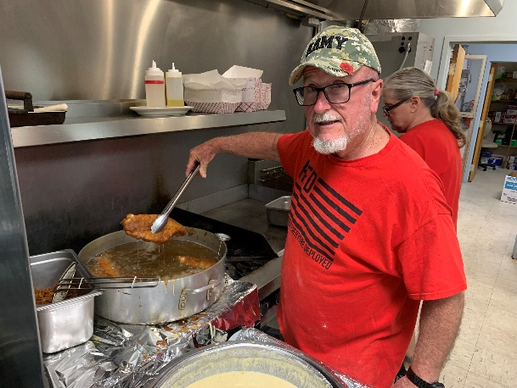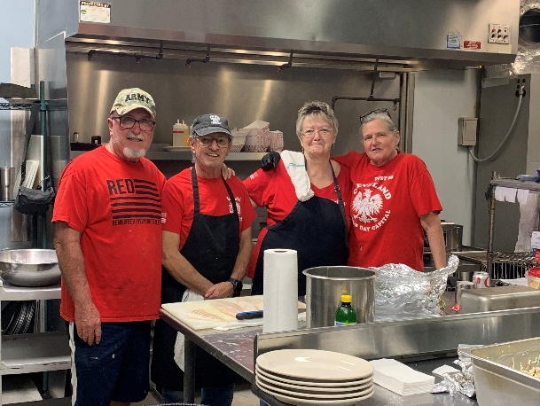
“Master Fryer” MIKE MISHOE shows off one of the scrumptious pieces of fried fish that was served during YOUR Post’s annual Lenten Season Fish-Fry-Friday.
Picture 2: is Fry Team members MIKE MISHOE, Commander BOB SEDELOW, Auxiliary President MO SEDELOW and Culinary Queen CAROLYN MISHOE
THANK YOU to everyone who worked so hard to make this Fish Fry the success that it was !!!!

**It is House Committee election time. Make sure you attend the May 9th Business meeting and vote for your favorite House Committee candidate. Or maybe, vote for yourself as a candidate for one of the up to seven (7) positions available.
Unlike Post elections, the new House Committee members assume their duties right after they have their first business meeting and elect a Chairperson and elect/appoint a Secretary .

For those that say a House Committee member cannot hold two elected positions (lets say Jr. Vice & House Committee), they are incorrect. The not holding two elected positions ONLY applys to VFW positions. The only two people who cannot get elected to the House Committee are the Commander and Quartermaster. By nature of their responsibilities (and according to Post By Laws) they serve as ‘honorary, NON voting, members of all Post Committees.
------------------------------------------------------------------------------------------------------------
VIETNAM VETERANS – As of June 2025 it was estimated that less than 23% of my fellow, in country, Vietnam Veteran brethren are still with us.
----------------------------------------------------------------------------------------------

YOUR 2026-2027 LEADERSHIP TEAMS
POST AUXILIARY
Commander: FRED SCHOMBURG President: DEBBIE SUMMIT
Sr. Vice Commander: GREG LEE Sr. Vice President: BILL MOORE
Jr. Vice Commander: JEFFREY BOEDER Jr. Vice President: SHAWN KELLEY
Quartermaster: BOB FAZEN Treasurer: MARY SCHOMBURG
3 Year Trustee: JACK MINNITI 3 Year Trustee: DEBBIE HARTLEROAD
2 Year Trustee: CAROLYN MISHOE Conductress: RAMONA SEALS
1 Year Trustee: NICK CAMERA Guard: JUDY POVADSHAW
Chaplain: KAREN CAMERA
NOTE: The Post Commander will be appointing personnel to the following positions:
Chaplain, Judge Advocate, Surgeon, Adjutant, Officer of the Day, Guard, Benefits Advisor.
The HOUSE COMMITTEE will be holding its elections at the May meeting. There are seven positions available. The following members have nominated themselves for consideration: KEITH BACON, MIKE BISHOP, FRANK HOERSTER, CHARLIE MARTIN, MIKE PHELPS, GREG LEE, CHRIS McPHERSON, WALT DUNCAN, JIM RISSER
YOUR Post also elected 20 delegates for the upcoming year.
*There will be a joint installation of officers immediately following the normal business meetings on MAY 9th. A pot-luck lunch will be provided.
My notes from the April 11th Business Meeting:
*YOUR Post welcomed new member MATTHEW KOGUT and transfer member LEON REED. We hope to see you at YOUR Post in the very near future.
*The CASH RAFFLE TICKET sales for the new Post Road Sign are going well. If you are interested in getting a ticket or two, contact JEFF BOEDER at guarddogg128@hotmail.com, OR stop by the post and see the bartender.
*The Quartermaster is selling Post Challenge Coins (to raise money for the canteen) at $10ea. You can contact him at robert@fazen.org
*NICK CAMERA reported that Post Community Activity numbers are: 1,152 community volunteer hours with a value of $19,758
*ASAP product for this month is CANNED FRUIT, drop your donations at the post.
*CAROLYN MISHOE reported the Lenten Friday Fish Fry netted the post $3,500.
*The April HOUSE COMMITTEE meeting did not happen because there were not enough members present to constitute a quorum.
*YOUR Post voted to support a Little league Baseball Team again this year with up to $500 going towards purchase of team uniforms.
*YOUR Post voted to give $200 to each to the top JROTC Cadets in the five high schools contacted that provide top cadet information to the post.
* THE NEXT POST MEETING WILL BE SATURDAY, MAY 9th


STATE HEADQUARTERS PROPERTY – Some of you may be aware that there has been a movement towards selling the state headquarters property in Lexington and going to a virtual (electronic) headquarters means of administering to the State VFW and all its Posts and members. There are those that believe there is no need for a “physical” headquarters and that by selling the property the State could save tens-of-thousands-of-dollars in operating cost and put several hundred thousand dollars in the bank for future SC VFW needs.
This Photo by Unknown Author is licensed under CC BY-NC-ND
One of the prime agenda items at the April 11th meeting of the Council of Administration was the sale of the State headquarters property. The vote to sell was soundly rejected.

HAPPY 109th Birthday, Post 10804 member and WW II Veteran GUS PRENO
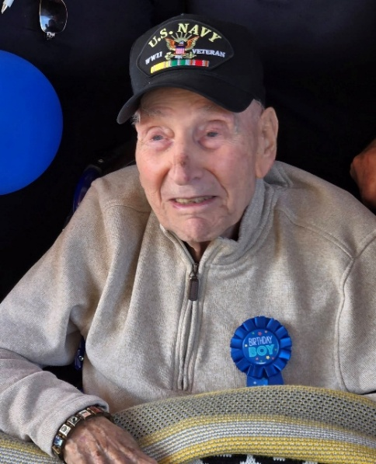
Gus served on the Destroyer Tender USS Melville during the DDay Invasion
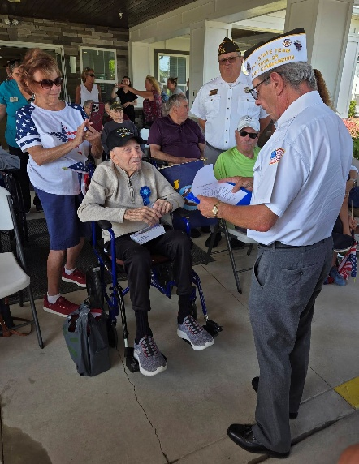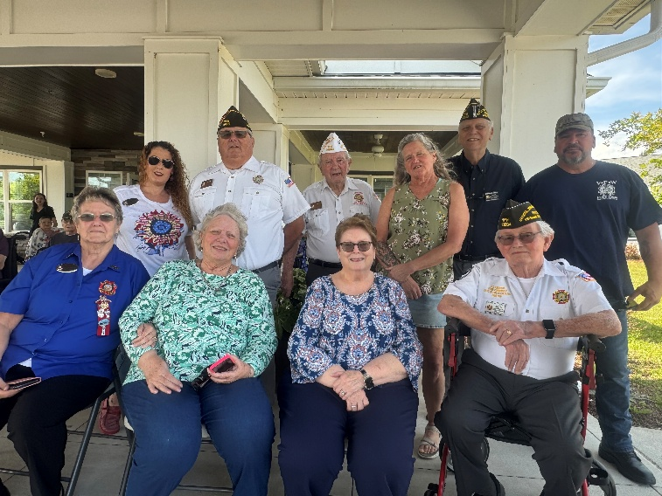
Picture 1: Commander Sedelow presenting Mr. Preno with a VFW Commander-in-Chief Special Citation of Recognition
Picture 2: Some of YOUR Post and Auxiliary members who attended the Birthday celebration. Some members not pictured because they were in the motor parade



Trust in the VA on the rise
(something John Brough does NOT want to hear)

*82% - This is what the Trust in the VA rating was for the 1st quarter of 2026
*93.6% - This is what the trust in the VA Outpatient Health Care rating was for the same time

The quarterly VA Trust survey measures the overall ease, effectiveness and emotional resonance experienced by Veterans. This quarter hit record highs:
- 77.3% of Veterans said it was easy to get the care or services they needed.
- 81.4% said they got the care or services they needed.
- 79.5% said they felt like a valued customer when interacting with VA.​
Veterans’ feedback is essential for improving services across VA. Since May 2016, VA has sent nearly 124 million digital surveys and received more than 17.8 million responses—including over 6.1 million free-text comments where Veterans describe their experiences in their own words.

QUESTION: What U.S. military medals have the name of the recipient inscribed on the back of the medal??

The Medal of Honor and the Distinguished Service Cross are the only two.
NOTE: In some cases, Purple Heart Medals are inscribed. But these are only done for recipients who are recognized long after the fact. Example: I had a friend who was awarded a Purple Heart in 2020. He actually earned the Purple Heart during the early days of the Korean War (1951). His name (and other info) was inscribed on the back of the medal.


Amazon is testing a new Drone delivery system. The problem is that once the drone gets to the delivery location. It looks for a clear spot to make the delivery (most cases the driveway) and DROPS the package from about 10 FEET ABOVE the ground.
I guess “fragile-handle with care” is NOT in their vocabulary!!


This Photo by Unknown Author is licensed under CC BY-NC
SOME SEVERE WEATHER TIPS YOU DON’T SEE:
1. If taking cover from a tornado and you have time, make sure you have;
a. Some sort of head cover, even a pillow
b. Some sort of body cover, like your bed quilt (you want to cover as much of your body as possible to avoid cuts from flying debris)
c. Footwear that has a strong sole (not flip-flops, croc’s, shower shoes, etc). Once the storm passes and you have to go outside, you want protection for your feet if having to walk in any debris.
d. Gloves – For protecting your hands if having to handle any debris.

IT IS NOW HURRICANE SEASON – Do you have your Hurricane Survival Kit ready (both in the home and for the car)? If you’re going to “ride-it-out”, do you have enough non-perishable food, drinking water and non-drinking water (like filing up a bathtub for personal cleaning and for toilet and sink use).
Is your vehicle full of gas? Do you know your Hurricane Evacuation Route (and alternates)?

For those of us that live near the coast. Anyone from North Myrtle Beach North who lives EAST OF THE INTERCOASTAL WATERWAY. You are in ZONE B and your evacuation route is ROUTE 9!
Anyone WEST of the Intercoastal, there is no evacuation zones for us, but ROUTE 9 is your primary way out! (Hwy 501 and Hwy 22 also) Evac Zones are only for TIDAL SURGE. Everyone else be hurricane safe!


DID YOU KNOW – That Horry County is the only county in S.C. that has two county police departments? Horry County Police & Horry County Sheriff.
This Photo by Unknown Author is licensed under CC BY-SA
There is a move within state politics to dissolve the Horry County Police Department and move part of it into the Sheriff’s Department.


PRESIDENTIAL LIBRARIES – How they work:

When an ex-Presient wants to build a Presidential Library. They must secure personal, private and public monies to build the building/s. Once the building is complete. The National Archives and Records Administration takes over the control and operating costs of each library. The standard acceptable size is 70,000 sq ft or less. Anything over 70,000 sq ft requires more private money be obligated to the library (there is a formula for this).
Last year, NARA required $109 million Congressionally appropriated funds (taxpayer dollars) to administer to the Presidential Library program.
In 2024 the Presidential Libraries took in over $6 million in tourist fees and an additional $1.5 million in library store sales. NONE of this money is used to offset the cost to the taxpayers. Each library gets to keep whatever fees and sales they get.


A FINAL SALUTE : In 2025 a total of 23 members of our military died in 14 far off locations around the world. Of the 23, only two died of hostile actions (in Sxyria).
The DoD does not provide information on service member deaths in the U.S. The only thing they report is that; since 2001 there has been a total of 7064 US military that have died.
REST IN PEACE!

VA - The VA receives millions of claims from Veterans each year for disability benefits and continues to process them faster than ever while maintaining high accuracy rates. This means more Veterans are receiving the benefits they’ve earned through their service on a timely basis. For example:
- After processing a record of more than 3 million claims in fiscal year 2025, VA is on a similar pace in FY2026 and has processed more than 1.5 million claims halfway through FY2026.
- In FY2026, VA completed 1 million disability claims faster than ever and hit this milestone on Feb. 2, 2026.
- VA’s claims-processing accuracy has increased to 94.02%, which is the highest 12-month accuracy rate in the last two years.
- The average number of days needed to complete a claim has fallen from 141.5 days to 80.7 days since the start of the second Trump Administration, a 43% decrease.
VA also receives hundreds of thousands of claims for Veterans Pension, Survivors Pension, and Dependency and Indemnity Compensation each year. DIC benefits are for the surviving spouses, the children, or the parents of a service member who died in the line of duty or through a service-related injury or illness.
During the second Trump Administration, VA has stepped up its levels of service to ensure Veterans and Survivors receive the benefits they deserve:
- In February, the backlog of Veterans waiting for VA benefits fell to less than 100,000 claims for the first time since 2020.
- VA has decreased the average time to complete an initial Veterans Pension claim from 170 days to 57 days, a 66% reduction. The average time to complete an initial Survivors Pension claim has dropped from 172 days to 73 days, a drop of more than 55%.
- VA has nearly eliminated initial Veterans Pension claims that are part of the VA disability claims backlog (older than 125 days), reducing this backlog from 3,514 claims to just 71 claims, a 98% reduction. The Survivors Pension backlog has decreased from 3,391 claims to 115 claims, a 96% reduction.
- The average time to complete DIC claims has dropped from 163 days to 73 days, a decline of more than 50%.
- The number of DIC claims in the VA disability backlog (older than 125 days) has dropped from 13,501 claims to 2,257, an 83% reduction.
Additionally, VA has cut the average time to complete burial claims from 70 days to 31 days, a reduction of more than 50%.

WW II HISTORY:

How many know when WW II officially started/ended for the U.S.?

December 8, 1941 the U.S. declared war on Japan. September 2, 1945 Japan surrendered.
(September 2nd is better known as V.J. day)

December 11, 1941 the U.S. declared war on Germany. May 8, 1945 Germany surrendered.
(May 8th is better known as V.E. Day)

Meet District 7 Commander (elect) GREG LEE
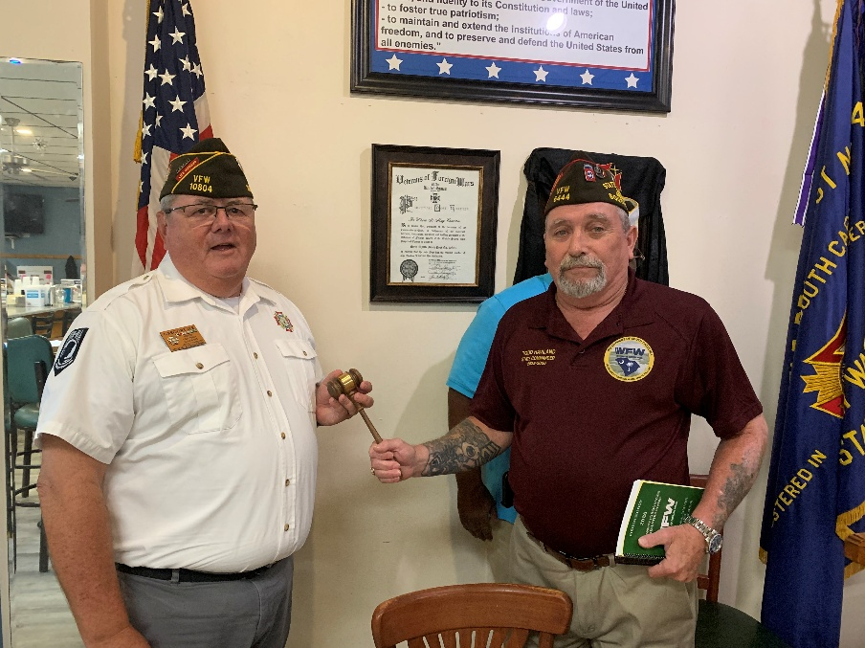
State Commander Todd Haviland presenting the District 7 Commander’s gavel to our very own GREG LEE

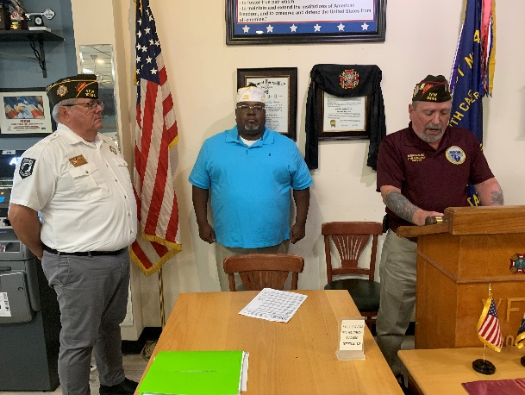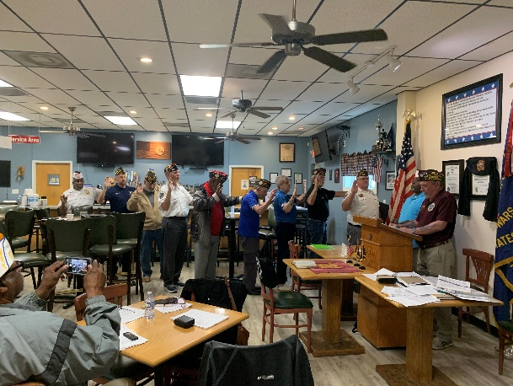
Picture 1: Newly elected District 7 Commander GREG LEE with outgoing D 7 Commander Vincent Staggers and State Commander Todd Haviland
Picture 2: All of the newly elected District 7 officers taking their oath of office. They include NICK CAMERA as D 7 Sr. Vice Commander and FRED SCHOMBURG as a D 7 3 Year Trustee
This is the first time in 12 years that I have not held an elected position in District 7 (my choice). THANKS for the memories!

***The big issue at the D 7 meeting was missing District funds. This was identified at the december meeting. The D 7 Quartermaster has been looking into the issue, but has been unable to find out where the money went and who possibly took it. There is a CD for $2,808 that was cashed and the monies disappeared. There was $3,862 taken from the D 7 Relief Fund and the District General Fund had around $5,000 taken from it. All monies UNACCOUNTED FOR!
At this meeting the District authorized the QM to get with the Banks in question and have a BANK AUDIT done on the D 7 Account. The bank charges $25 an hour and the District authorized up to 8 hours bank audit time.
**The D7 By Laws require there to be at least $2,000 in the District Relief Fund. Since that fund currently sits at $ZERO. The District authorized a $2,000 transfer from the General Fund to the Relief Fund.
*** All investigations to be completed by the next District 7 meeting which is tentatively planned for sometime in July.
-----------------------------------------------------------------------------------------

THANK YOU!! For the Memories from Commander BOB SEDELOW and Auxiliary President MO SEDELOW

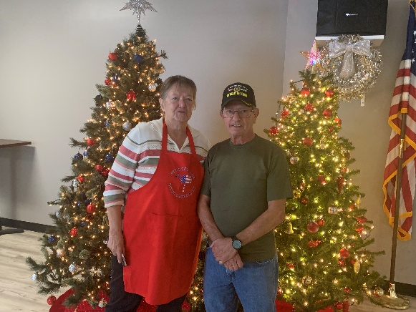

Commander BOB SEDELOW: I can hardly realize that two years have passed since I first appeared before you to take my oath of office as Commander of our VFW. The intervening years have been full and at times difficult.
If I haven’t expressed my deep appreciation for the wise counsel and unwavering support I have received from the post, officers and comrades alike, for your sacrifice of time
and energy I do this now.
To those that will be the leadership in the next year, I know you will supply the necessary inspiration and enthusiasm to carry our aims into effect and that your administration
will be remembered as one of the most successful. I feel my accomplishments out way some of my shortcomings that I regret. I hope the post is satisfied with my tenure as your Commander.
Thank you for your confidence in me over the past two years.

Bob Sedelow
Commander 2024-2026
North Myrtle Beach
VFW Post 10804

Auxiliary President MO SEDELOW - As I will be passing the Auxiliary President gavel to our new incoming Auxiliary President (Debby Summitt) I wish her the very best and any support she needs from me.

I want to take a moment to express my deepest gratitude and forever grateful to the officers, chairpersons, mentors and especially all our members for their support to me and our auxiliary, their commitment to support our auxiliary in so many ways, behind the scenes, monetary, your time, taking on being an officer, a chairperson of our programs, without your commitments we would not of had a successful year after year. It wasn't just the big projects but the truly dedication in the little things that made the difference. THANK YOU
Someone has said, I was in it for the glory ... Oh so wrong. It wasn't me accomplishing all the Auxiliary has done...It was each and every one of our members and our comrades who made everything we have done a success.
THANK YOU ALL for your continued service and for being such a valuable part of our Auxiliary which means so much to me.
I will forever treasure the friendships I have made in this Auxiliary and Post.

Reminder ... We will be having our annual "Christmas n July" dinner and baskets on July 18th. Please contact me if you are able to donate a basket
Maureen Sedelow
Auxiliary 10804 President

With this edition of the Post Newsletter, I close My book on being the Post Newsletter Creator/Editor/Writer for the last nine years. I hope someone out there takes up the challenge, supports Commander Schomburg, and produces some sort of Newsletter/Bulletin that will keep all post members informed.
THANK YOU for your support of what I have done!

Bill La Monte
Writer/Editor

